Year 4 Term 6 Newsletter
Dear parents of year 4:
We hope you are all excited to start the last term of Year 4! We are looking forwards to starting our new topics this term. If you have any questions, please do not hesitate to contact us on Class Dojo.
Please remember this term… reading books and planners in school every day.
Otters have Forest School on a Wednesday morning and outdoor PE on a Friday afternoon.
Foxes have outdoor PE on a Monday and Wednesday.
Thank you!
As Coningsby Scientists we will:
Be learning all about electricity! Our science topic starts off with us exploring static and current electricity. We will be making different circuits to see if they work. We will also investigate the differences between mains and battery powered circuits. We will discuss some common conductors and insulators and associate some metals with being good conductors. We will then use this knowledge of conductors and insulators to create circuits with switches.

As Coningsby Mathematicians we will:
Start the term by looking at 2D and 3D shapes and discussing their properties. We will then look at identifying different angles as well as comparing, and ordering angles. We will move on to look at triangles, quadrilaterals, and polygons. Towards the end of the term, we will look at interpreting bar charts and line graphs and we will finish the term by looking at plotting co-ordinates on a grid.
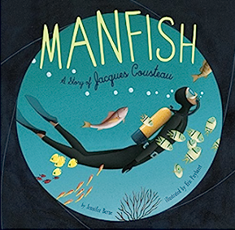
As Coningsby Geographers we will:
Be naming and locating counties and cities of the United Kingdom. We will be looking at geographical regions and identifying human and physical characteristics including hills, mountains, coasts and rivers. We will understand how the land is used in our local area and how this has changed over time.

As Coningsby Authors we will:
Be exploring our book, Manfish: A Story of Jacques Cousteau by Jennifer Bernet. This is a beautifully illustrated biography of a little French boy who goes on to become an internationally known oceanographer and champion of the seas. We will be writing an invention narrative, using our amazing imaginations to invent our own device. We will also be writing a biography about Jacques Cousteau towards the end of term.
As Coningsby believers we will:

Be continuing our learning about pilgrimage across different faiths. We will begin our learning by recapping what we can remember about Hindu beliefs. We will discuss Muslim beliefs and in particular, the Five Pillars of Islam. We will finish our learning by discussing how Pilgrimage impacts the Environment.
As Coningsby Artists & Designers we will:

Be doing digit art! We will be creating digital images using a technique called pointillism. We will then look at the artists Mondrian and Picasso and discuss examples of their work. We will produce our own attempts of a Mondrian-and Picasso inspired piece of art. We will finish the term by creating our own pop art inspired by the artist Andy Warhol.

