
Year 5 Maths
KEY INSTANT RECALL FACTS
(KIRFs)

To develop your child’s fluency and mental maths skills, we have introduced KIRFs (Key Instant Recall Facts) throughout school. KIRFs are a way of helping your child to learn by heart key facts and information which they need to have instant recall of.

KIRFs are designed to support the development of mental maths skills that underpin much of the maths work in schools. They are particularly useful when calculating: adding, subtracting, multiplying or dividing. They contain number facts such as number bonds and times tables that need constant practise and rehearsal, so children can recall them quickly.

Each half term, children will focus on 2 KIRFS to practise and learn at home alongside the work that we will be doing weekly in school. They will include ideas to assist your child in grasping these key facts. They are not designed to be a time-consuming task and can be practised anywhere – in the car, walking to school etc. Regular practise – little and often – helps children to retain these facts.

Over their time at primary school, we believe that – if the KIRFs are developed fully – children will be more confident with maths work, understand its relevance and be able to access the curriculum more easily. They will be able to apply what they have learned to a wide range of problems that confront us regularly.

Thank you for your support.
Key Instant Recall Facts
Year 5 Summer 2

This half term your child is working towards achieving knowledge of the KIRFS, indicated below.
The ultimate aim is for your child to be able to recall these facts instantly.
This term’s KIRF 1……  I can multiply together three single- digit- numbers | For example:  Build arrays to work out the answer-  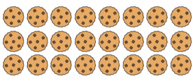  3 x 8 x 2=  Multiplication is commutative. You can alter the order to make a calculation more simple-  3 x 8 = 24  24 x 2 = 48
Key Vocabulary:  Volume  capacity | Play a game:  Use pasta or counters to build arrays  Roll a die to generate numbers to multiply together.  Make 0-9 digit cards. Choose three. Play around with the order of your multiplication
Online games to practise:
Learn to multiply 3 numbers - Maths - Learning with BBC Bitesize - BBC Bitesize

This term’s KIRF 2……  I know fraction, decimal and percentage equivalents of ½, 1/5, fifths and tenths | You will need to know these facts.  ½ = 50%= 5/10= 0.5  5/10 =1/5 = 20% = 0.2  1/10 = 10%= 0.1  3/10 = 30% = 0.3
Key Vocabulary:  Equivalent  Percentage ( out of 100)  Fifths tenths | Play a game:  Play the jigsaw puzzle game on the class webpage.  Make the facts above into cards and play a game of pairs  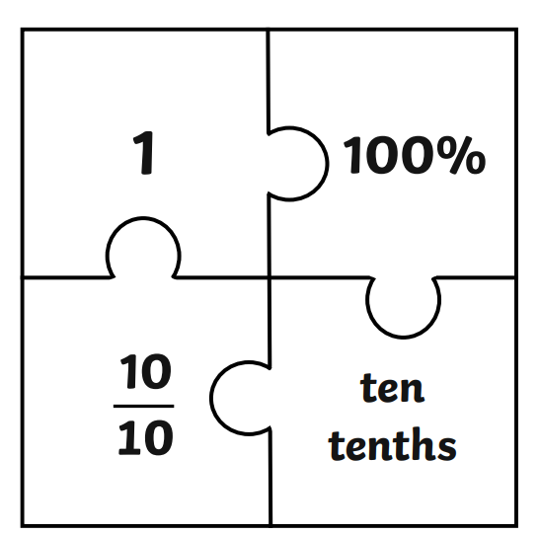
Online games:
Match Fractions Decimals and Percentages - Mathsframe

