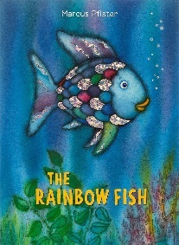


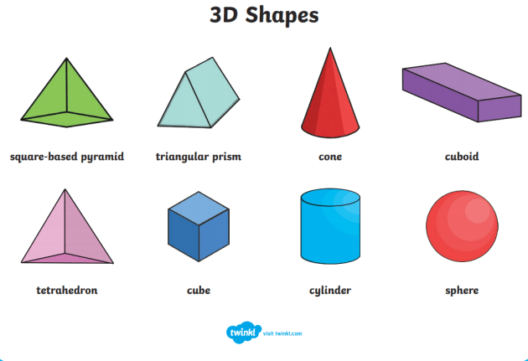
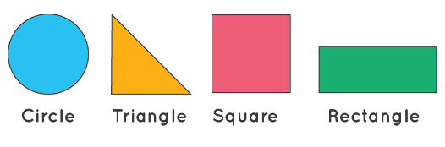

This term, we are focusing on our school value ‘truthfulness’ and our Bible story is ‘Jacob and Esau’.
Please continue to send children in to school on Mondays wearing P.E. kit and carrying wellies. Children will need school shoes and uniform to change into after their forest school and P.E. session. Children will also have a JB Sports P.E. session on Thursdays. P.E. kits can be worn to school on Monday and brought home on Thursdays.
June 20th: Sport’s Day.
July 5th: Annual reports to parents.
July 15th: Stay and Play, 2.30pm
July 8th: Transition week.
July 19th: last day of term.
In History, we will be considering how we ourselves have changed over time, and looking at how seaside holidays are different today than they were for our grandparents.
We will be learning about Stephanie Kilgast in our Art sessions and exploring lots of different materials to make sculptures with.
Please ensure that your child has a named sunhat in school every day and arrives at school wearing suncream. Please also pack a light waterproof for those inevitable days when the rain makes an appearance. It is a good idea to send a waterproof jacket every day, just in case.
Our Science topic is ‘Living Things and their Habitats’, which ties in well with our R.E.
In R.E, our topic will be ‘Our Wonderful World’ and we will be appreciating and looking after the world around us.
In Maths, we will be learning more about numbers; shapes and patterns. We will find out about odd and even numbers; create more complex repeating patterns; dive deeper into 2D and 3D shapes, and begin to look at the clock as we talk about ordering events in our day.
In Literacy, we will be exploring the stories; Billy’s Bucket; Rainbow Fish; and Tiddler. We will be focusing on constructing sentences and simple phrases; thinking about how the characters feel and talking about our feelings too.
Our Key Instant Recall Facts this term, are - to know which pairs make a given number to at least ten; and to automatically recall number bonds for numbers to at least five. These are ideal for practicing in the car or on the walk to school.
Welcome to the final term of this academic year. The children have grown and achieved so much this year – we are all so very proud of them and hope that you are too!
Summer Term 2

