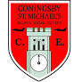
Year 5 Maths
KEY INSTANT RECALL FACTS
(KIRFs)

To develop your child’s fluency and mental maths skills, we have introduced KIRFs (Key Instant Recall Facts) throughout school. KIRFs are a way of helping your child to learn by heart key facts and information which they need to have instant recall of.

KIRFs are designed to support the development of mental maths skills that underpin much of the maths work in schools. They are particularly useful when calculating: adding, subtracting, multiplying or dividing. They contain number facts such as number bonds and times tables that need constant practise and rehearsal, so children can recall them quickly.

Each half term, children will focus on 2 KIRFS to practise and learn at home alongside the work that we will be doing weekly in school. They will include ideas to assist your child in grasping these key facts. They are not designed to be a time-consuming task and can be practised anywhere – in the car, walking to school etc. Regular practise – little and often – helps children to retain these facts.

Over their time at primary school, we believe that – if the KIRFs are developed fully – children will be more confident with maths work, understand its relevance and be able to access the curriculum more easily. They will be able to apply what they have learned to a wide range of problems that confront us regularly.

Thank you for your support.
Key Instant Recall Facts
Year 5 Spring 1

This half term your child is working towards achieving knowledge of the KIRFS, indicated below.
The ultimate aim is for your child to be able to recall these facts instantly.
This term’s KIRF 1……  I can multiply and divide numbers involving decimals by 10, 100 and 1,000. | For example:  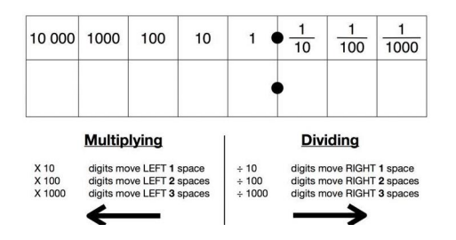  Just like when we multiply whole numbers by 10, 100 and 1000 we shift the digits to the left. One place left for 10, two places left for 100 and three places left for 1000. When we divide by 10, 100 and 1000, we do the opposite and shift the digits to the right instead. This is the same for numbers involving decimals.
Key Vocabulary:  Multiply  Divide  Whole number  Decimal number  Place value | Play a game:  Try some real-life examples of converting pounds to pence, kilograms to grams and centimetres to millimetres and meters.  OR  Make your own Gattegno chart to help you remember what happens when we times a number by 10, 100 or 1000.
Online games to practise:
Multiplying decimals by 10, 100, and 1000 (article) | Khan Academy

This term’s KIRF 2……  I can find multiples of a given number. | A multiple of a number is a number that appears in the times table. For example, 5, 10, 15, 20… etc are all multiples of 5, and they can all be divided by 5.
Key Vocabulary:  Multiply  Multiple  Times table. | Play a game:  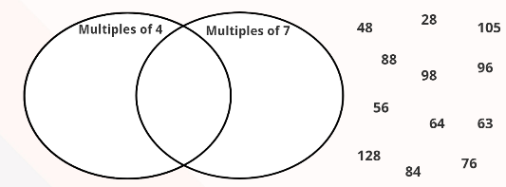  Can you create your own version of the Venn diagram?
Online games:
Multiples and Factors (topmarks.co.uk)
Factors and Multiples Game (maths.org)

