How to download learning journals and media from Tapestry
Over the last year we have collected photos and assessments of your child. These are available for parents to download as PDF or zip file copies. Below are instructions on how you can download your child’s Tapestry learning journal.
Alternatively you can bring a named memory stick into school and your class teacher will download Tapestry and put it on for you.
Downloads are only available for 28 days after being created, so don’t delay downloading if it’s possible.
Please note that PDF and media downloads are NOT available on the app version of Tapestry, and that you may need to download a special app to view PDFs on a mobile or tablet device.
Step 1: Log into Tapestry using the web browser version through our login page at https://tapestryjournal.com/.
Step 2: Click on your username at the top right of the screen and select ‘Downloads’ from the drop down list.
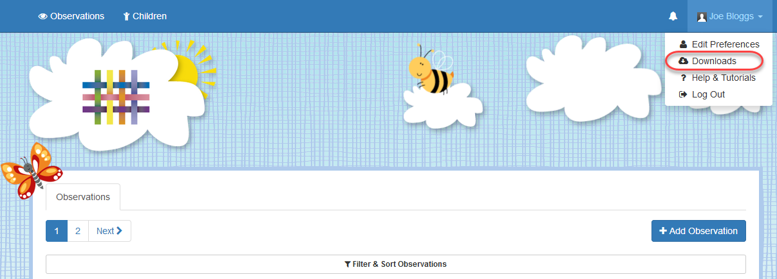

Step 3: On the Downloads page you should see all downloads you have available. Click the ‘Download’ button to download your PDF copy of the journal or ZIP file of the media.
Make sure you save your files somewhere safe and if possible save it to permanent storage off your PC (such as a CD or external hard drive), marking it so you will be able to find it in the future. Remember, Tapestry records will usually be deleted once your child has left!
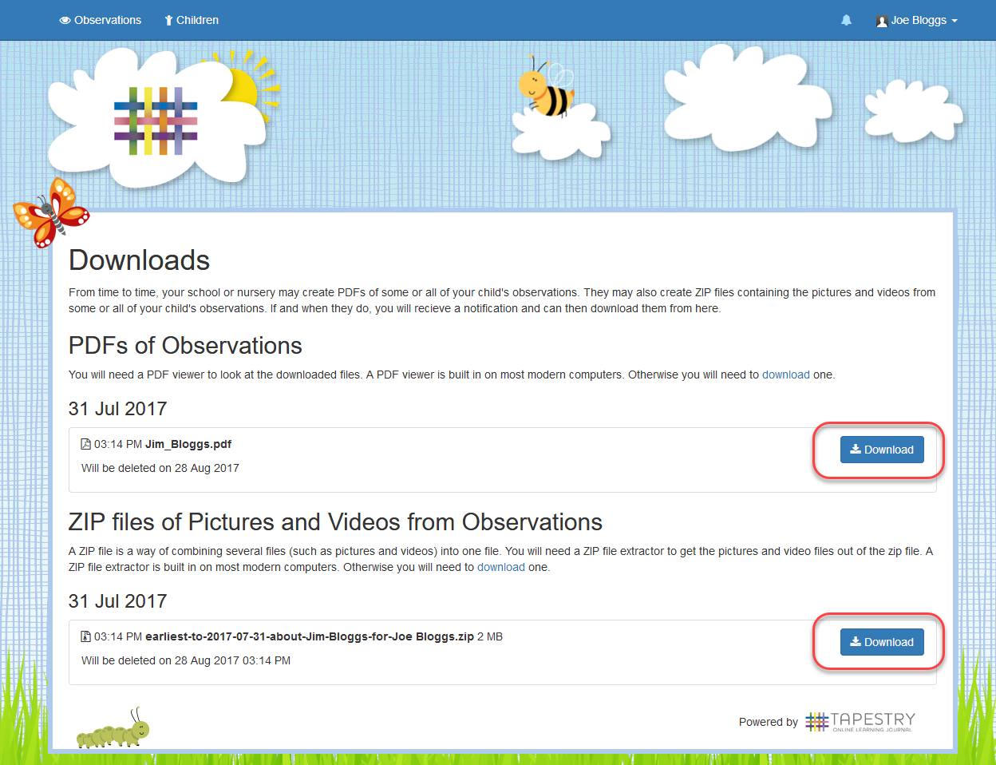
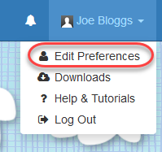
If you have any issues please do let your child’s class teacher know and we will do our best to help.

Many thanks,
The EYFS Team.

