In class this week, we are looking at this poem.
Task 1
Read this poem. What do you notice about the structure?
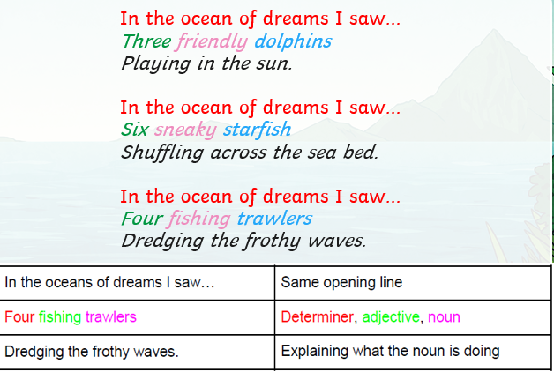
Task 2
Can you write your own verse for this poem, following the same structure?

In the ocean of dreams I saw…
______________________________
______________________________

In the ocean of dreams I saw…
______________________________
______________________________

Task 3
Think about what you might be able to see in a forest. Add some ideas to this planning grid.
In the forest of dreams I saw…
determiner | noun | adjective | what was it doing?

Task 4
Write your own poem, using your ideas from the planning grid.

In the forest of dreams I saw…
______________________________
______________________________
In the forest of dreams I saw…
______________________________
______________________________
In the forest of dreams I saw…
______________________________
______________________________
In the forest of dreams I saw…
______________________________
______________________________

