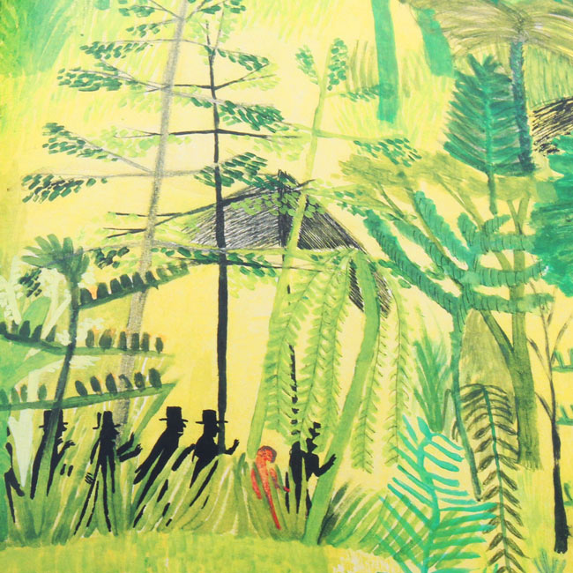
Task 1
Using this image and your own knowledge of jungles, create a bank of words and phrases to describe the jungle. Remember to use adjectives and different sentence openers.
Task 2
Write a description of a jungle. Try to create an image in the reader’s mind!
Task 3
Draw a picture of your jungle.

