JUST VISITING
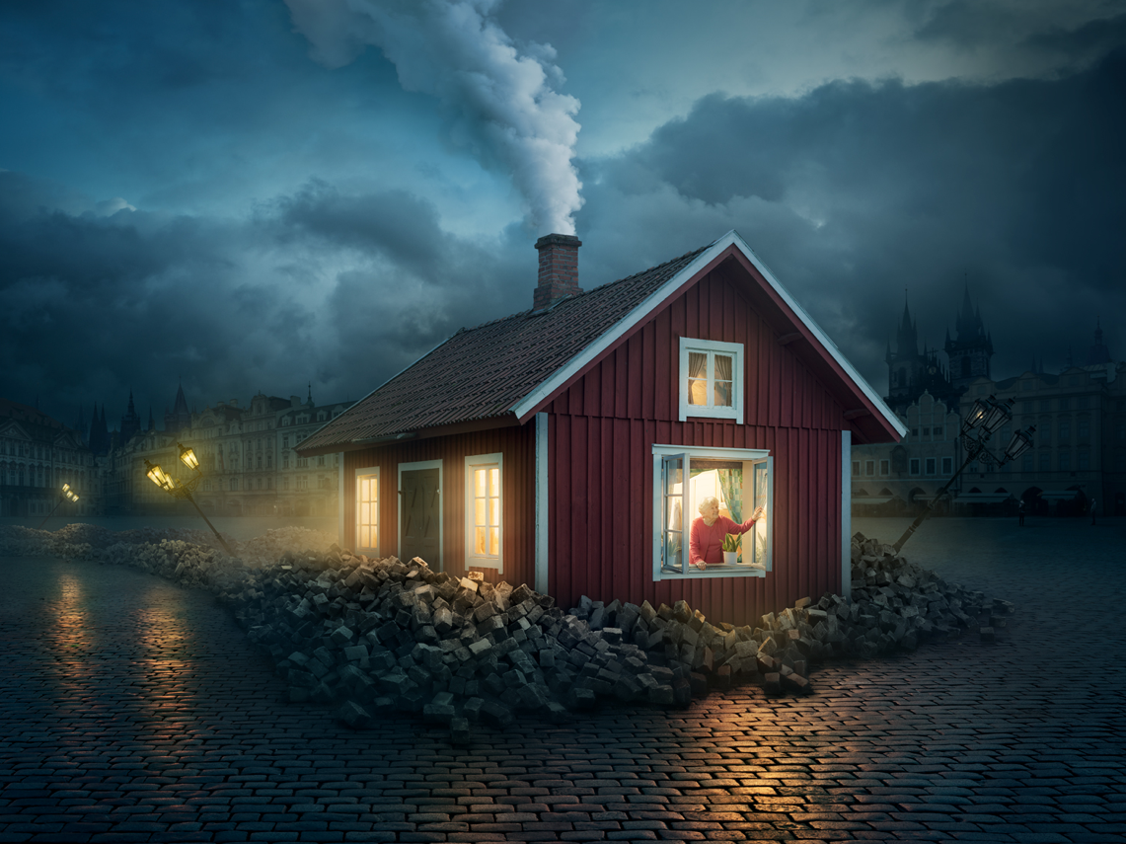
- What do you know about this picture?
- What do you think you know about this picture?
- What would you like to ask about this picture?
- Where did the house come from?
- How do you think it got here? (Which direction did it come from? How fast was it travelling?) Why is it surrounded by all of the bricks? What happened to the lampposts?
- Who is the woman inside the house? Was she bothered by the 'landing'? Give evidence to support your opinion.
- Why is she looking out of the window? What might she be thinking?
- Do you think she'll stay here for long? Why/why not?
- Do you think anyone else is in the house with her?
- Why do you think she came to this place? Where is this?
- If your house could travel, where would you like to go and why?

© Once Upon A Picture

