 | Class:  4B and 4E | Learning question for the term:  Why were the Romans so Powerful? |  |  |  |  |  | Science focus for the term:  Animals including Humans. | English Texts for this term:  Vesuvius Poovius by Chris Mould and Kes Gray  Roodica the Rude by Margaret Ryan
Below are some activities so that children can continue their learning during the school closure. Please send pictures of your home learning on Class Dojo. Miss Bennett, Miss Boole and Mr Edge will still be accessing Dojo during school hours Monday – Friday and would love to see pictures of activities the children complete!
Maths  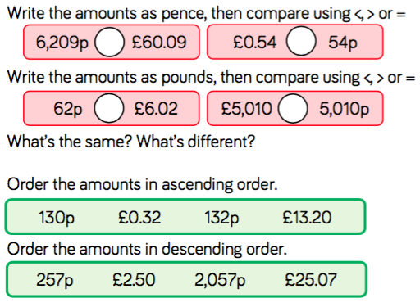 |  |  |  | French  See the separate activity attached. | English – Vesuvius Poovius  Imagine you are the emperor or the emperor’s wife and describe your evening at Vesuvius Poovius’ house in the form of a diary entry. Can you describe the feast, how you were feeling when you began to feel unwell and how you felt after discovering Vesuvius’ invention? |  |  |  |  |  | English  Can you write a persuasive letter to try and persuade Vesuvius Poovius to fix the problem of the unmentionables?
Art  Can you design your own Roman pottery?  First research some different Roman pottery and discuss what might the Romans have used them for, how they were made and how they were decorated. Then, design your own pottery and explain why you have used those colours and patterns. |  |  | RE  People can give their time, money and talents to look after everyone and everything. Think about times when you have done this. This could be raising money for charity or helping someone.  Write a short recount of the Compassion Fayre considering how you used your talents to raise money (We made Spicy Chickpea Pot to sell). |  |  | History  What do you know about Roman roads?  Can you research why the Romans wanted to build roads? Why were these roads so famous? The Fosse Way was one of the first great Roman roads in Britain. It ran from Exeter to Lincoln, passing through Bath, Gloucester and Leicester. Can you draw The Fosse Way on a map of England? Can you then design, plan and make 3D model showing a cross-section of a Roman road using the PowerPoint to help you? |  |  |  | Science  Do you know the types and functions of our teeth?  Visit http://www.skoool.com.eg/english/skoool_bundle/content/primary/science/teeth/index.html to learn about the types and functions of our teeth, then have a go at the quiz! As a challenge, you could also have a go at the activity sheets attached.
This is a picture of one of our new pygmy goats, which will be joining our CSM family! He and his brother will be moving into the Mystical Garden by the end of May. As a project for this term, try some of these activities:

- Research pygmy goats and create a fact-file about them.
- Research how to look after pygmy goats and create some instructions.
- Think of some names for our goats and write a persuasive letter convincing us to choose your name.
- Design a home and outdoor space for the goats to live in.

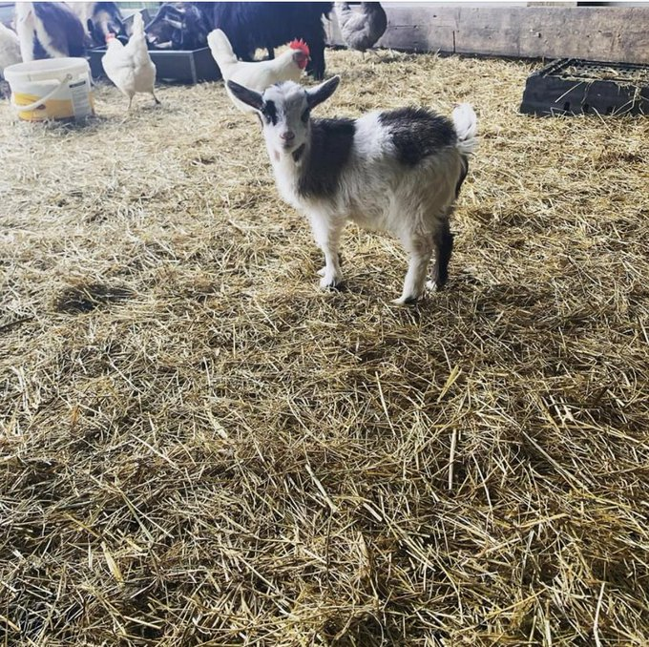
We hope that all of your wonderful work can form part of a display for the goats when we get back to school.
Reading – Children should be encouraged to read every day. Please spend 5 or 10 minutes listening to your child read and discussing their books. We would love to know about what books you have been reading, so why not write a book review when you have finished! |  |  |  |  |  |  | Maths – All children from Year 1 to Year 6 have all been provided with a log in for Times Table Rockstars or Numbots. Children should be completing at least 3x5 minutes each week. If you have lost/can’t remember your login, please contact Miss Bennett/Miss Boole or Mr Edge on Class Dojo.

