History Week Beginning 21.9.20

This week we are look at how life changed for poor children in Victorian times.

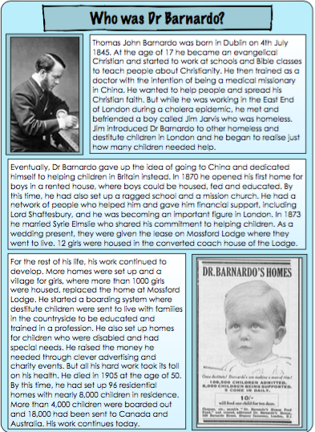
Read the following information about Dr Barnardo and then complete the character profile of him.


