Year 5 Term 3 Curriculum
Welcome back to our new term!

Please remember this term…
PE kits, reading books, planners in school everyday. Homework will continue to be sent home on Fridays and returned by Thursdays. Please have library books in school on Mondays, ready to be changed.

Please remember this term…

As Coningsby Scientists we will…

be exploring reversible and irreversible changes of materials and we will explore these changes through various investigations, e.g. look at the effects of melting and solidifying chocolate,
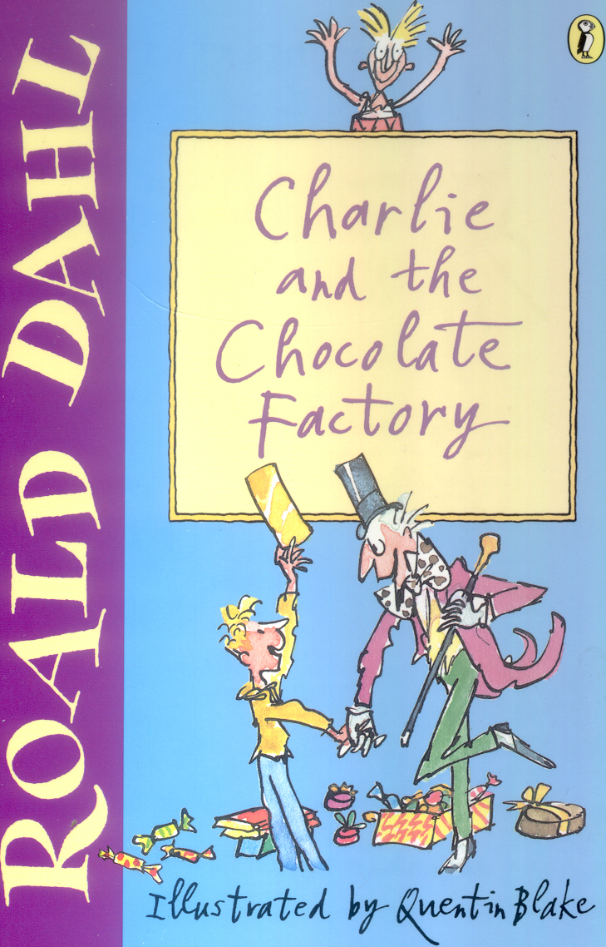
As Coningsby Mathematicians we will…

focus on methods of multiplication and division. We will work extensively with fractions, looking at equivalent fractions.
We will compare and order them and also learn to add and subtract them.

As Coningsby Authors we will…

be responding to our text for this term “Charlie and the Chocolate Factory”.
We will look closely at character and setting descriptions relating to our text and will introduce a further character of our own. We will be using persuasive writing to create adverts for chocolate products.

As Coningsby Geographers we will…

be learning about the use of rivers for trade and transport. We will be exploring the importance of Fairtrade for producers. A further focus this term will be on learning the countries that form Europe and their capital cities.

As Coningsby Believers we will…

read and discuss the Bible story – ‘Elijah and the widow of Zarephath’ and discuss our core value of Compassion.
In RE, we will be exploring Christianity. Focussing on what happened in the last days of Jesus’ life and how Jesus’ sacrifice saved human life.

Linking to our persuasive writing, as Coningsby Designers we will…

be evaluating existing chocolate products and designing and creating our own versions.

