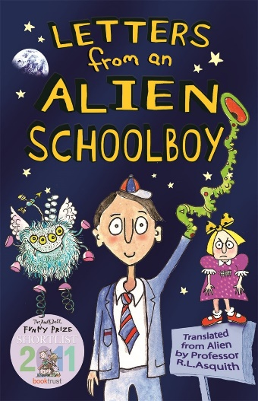
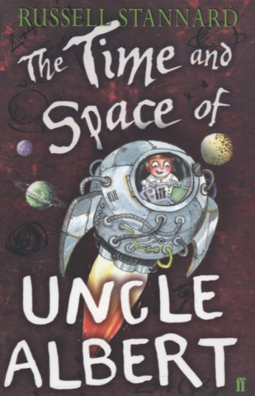
As Coningsby Mathematicians we will…
Identify multiples and factors of numbers, recognising what prime, square and cube numbers are and how to multiply and divide numbers by 10, 100, 1000. We will be calculating areas and perimeters of shapes. We will apply our learning through mastery (problem-solving) activities each week. We will also continue to use Times Table Rockstars which the children can access at home for further practice.
As Coningsby Scientists we will…

be looking at the planets in our Solar System and how their different orbits. We will use the Earth’s orbit to explain why we have day and night and investigate how the planets differ in size and what the differences are between them.

Year 5 Term 2 Curriculum

As Coningsby believers we will…
read and discuss the Bible story – ‘Solomon builds a temple – 1 Kings Ch. 6’ and discuss our core value or Perseverance.

In RE, we will be focusing on Islam. We will be learning how Muslim teaching guide them in their everyday lives and what the Qur’an teaches Muslims about how they should treat others.

As Coningsby Historians we will…

be learning about the Vikings and their culture. Our investigations will also look at how and when the Vikings raided and settled in England. We will also be looking at their beliefs and who they worship.
As Coningsby Authors we will…

be responding to our text for this term which is “Letters From An Alien Schoolboy” and “The Time And Space Of Uncle Albert. We will be writing our own letters, a detailed explanation text and creating our own Captain’s Log.
As Coningsby Artists & Designers we will…
be using our DT skills to create moon buggies where the children will design, build and evaluate their own work.
Welcome back to our new term!
Please remember this term…

PE kits, reading books, planners in school everyday. Swimming kits to be remembered on Wednesdays. Homework will be sent home on Fridays and to be returned by Thursdays. Please have library books in school on Mondays, ready to be changed.

