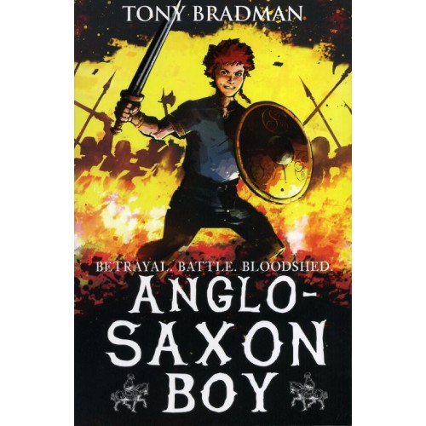
5 Term 1 Curriculum

As Coningsby believers we will…
read and discuss the Bible story – ‘Jesus and the children. Matthew 19 V13-14’ and discuss our core value or Friendship.

In RE, we will be looking at Hinduism. We will be drawing similarities and differences between Hindu and Christian beliefs and researching how worship takes place in each religion.

As Coningsby Mathematicians we will…
focus on place value, methods of addition, subtraction and statistics. We will continue to develop our mental arithmetic skills by improving our recall of key number facts. We will apply our learning through mastery (problem-solving) activities each week. We are also introducing Times Table Rockstars which the children can access at home for further practice.
As Coningsby Historians we will…

be learning about Anglo-Saxons and their culture – Why they settled in Britain, daily life, how they communicated, the Gods they worshipped and their influence on place names in Britain.
As Coningsby Authors we will…

be responding to our text for this term “Anglo-Saxon Boy” We will look closely at character descriptions and will create our own mythical stories.
As Coningsby Artists & Designers we will…
be using printing/painting techniques based around Anglo-Saxon artefacts. The children will also be designing and building their own Anglo-Saxon village.
As Coningsby Scientists we will…

be exploring the question ‘How different will you be when you are as old as your grandparents?’ This unit of work looks at the different life stages for humans and animals. We will also be discovering how to maintain a healthy body.

Welcome back to our new term!
Please remember this term…

PE kits, reading books, planners in school everyday. Swimming kits to be remembered on Wednesdays. Homework will be sent home on Fridays and to be returned by Thursdays. Please have library books in school on Mondays, ready to be changed.

