Week beginning 04.1.21

This work is to be completed by the children who are unable to currently attend school in Year 5.
Children should be encouraged to read every day. Please spend 5 or 10 minutes listening to your child read and discussing their books. All children from Year 1 to Year 6 have all been provided with a log in for Times Table Rockstars or Numbots. Children should be completing at least 3x5 minutes each week.
https://www.timestables.co.uk/

English Task 1
Using the video clip and the picture provided – create a setting description of the Bucket house, think about what it is like inside and outside – use your imagination as well as what you actually know. Make sure you include noun phrases within your description and see if you can think of any relevant similes to use.

SPaG Task 1
This week we are looking at prepositional phrases, use the attached video to help you create a list of words that are prepositions e.g. in, under and on. Have a go at using some of these in your own sentences to describe things you can see in your room e.g. my teddy is on the floor.
https://youtu.be/DYd7dg2I-9k

Reading Task 1
Please can you read a chapter of your book and explain what has happened in this chapter to an adult.

Maths Task 1
This week in maths, we are learning to multiply 3/4-digit by 1-digit numbers using effective methods. Have a go at being a teacher, can you spot any errors and correct them?
Watch the following Maths Antics Multiplication video which explains more about this.
https://www.youtube.com/watch?v=FJ5qLWP3Fqo&list=PLlYMa4OU-v6V817JyBx_Oi67lEEJfi1Wp&index=10&t=0s

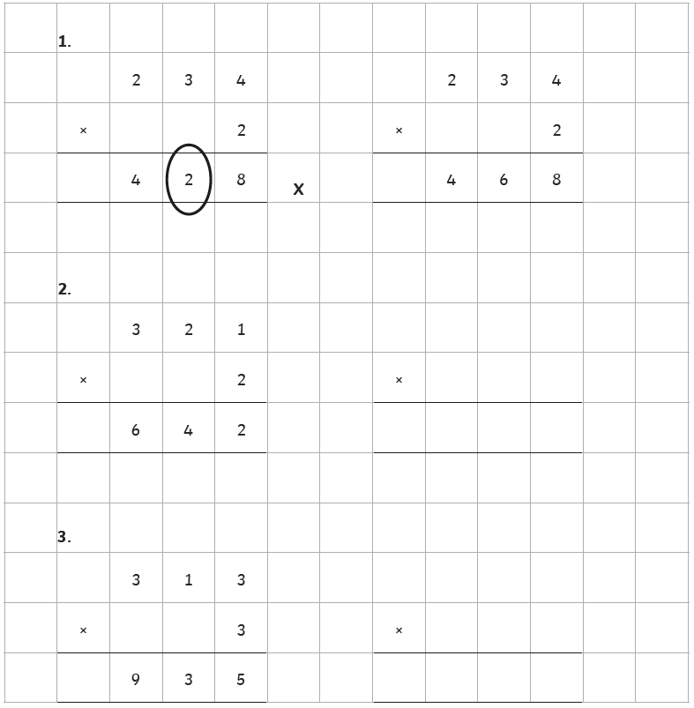

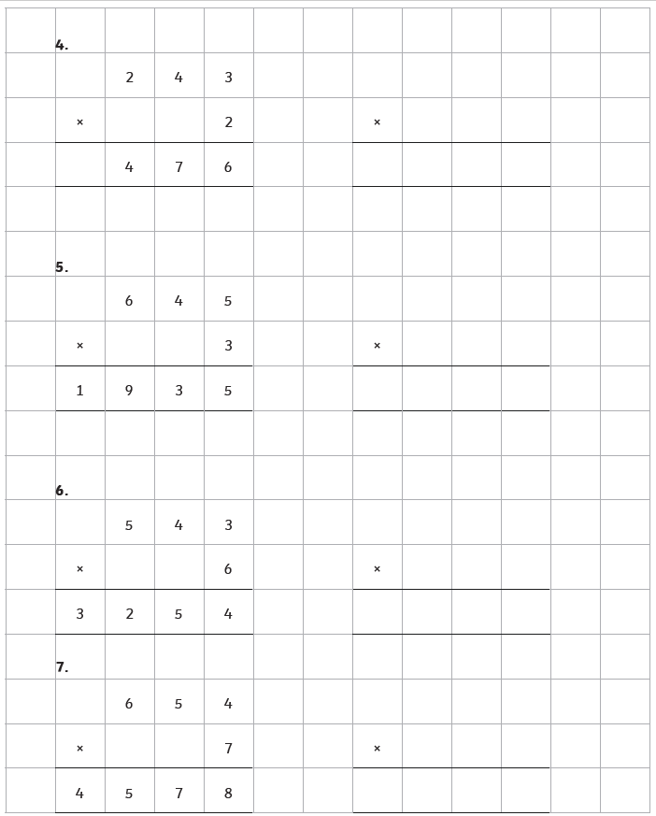

English Task 2
Create a thought bubble of what Charlie might imagine what the inside of the chocolate factory is like – what are the workers like, what do the machines look like, what sweets do they make? Firstly, draw your ideas – make this bright and colourful and then describe this in detail. Try not to think about the film too much and make sure you use your imagination.

SPAG Task 2
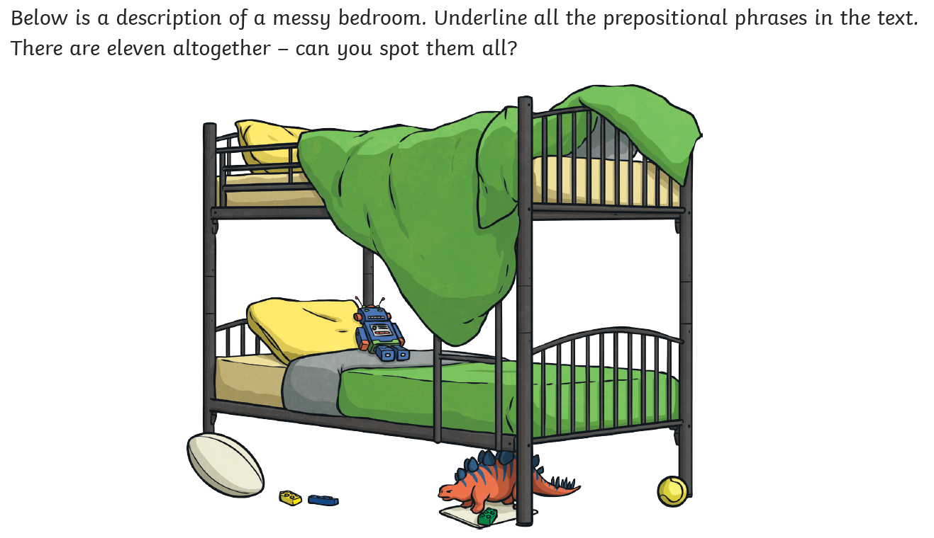

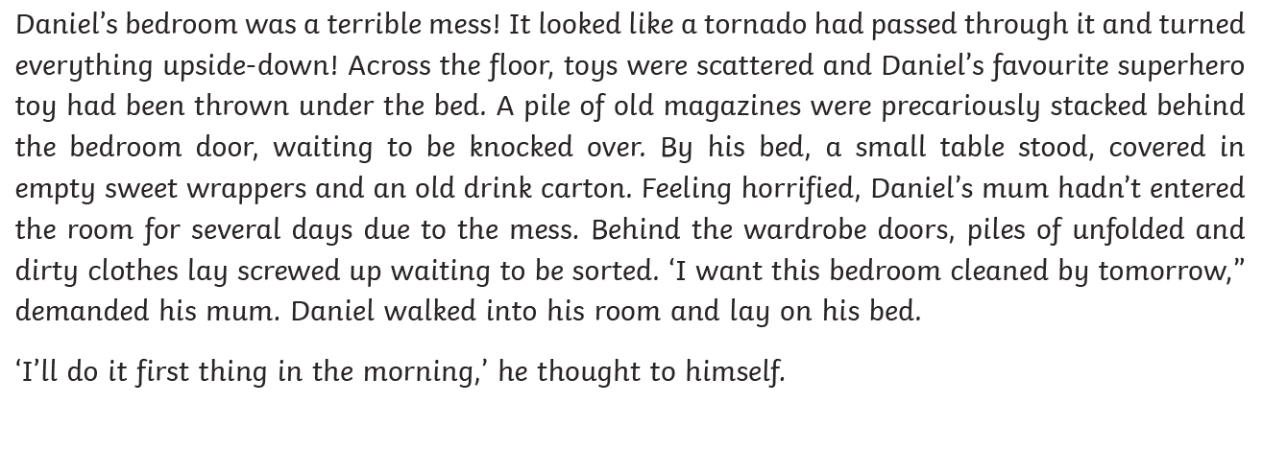

Maths Task 2
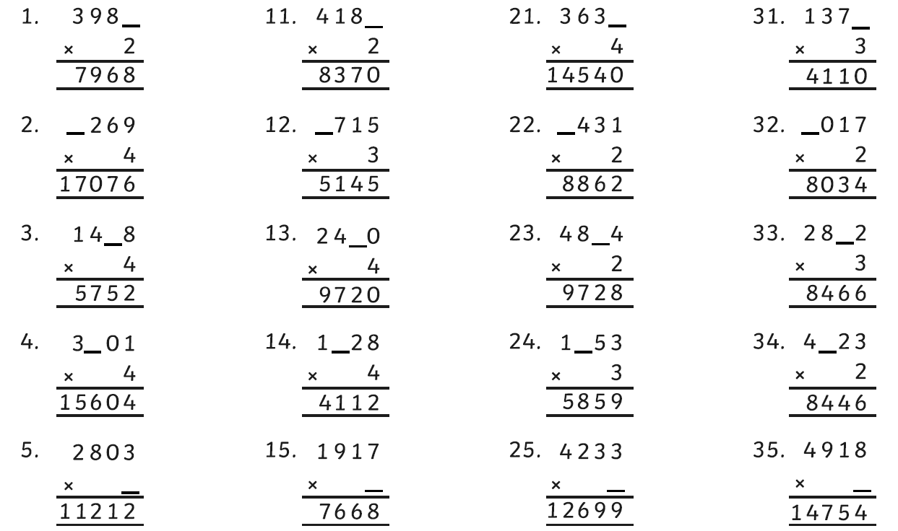
Can you identify the missing digits in the following calculations, make sure you remember to think about numbers that have been carried from a previous column?

Have a go at the challenge below but be careful as this is a tricky one!
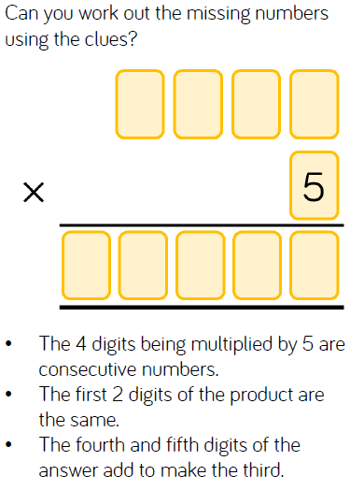

English Task 3

For those of you who were in school on Monday, we read the first two chapters of our text – Charlie and The Chocolate Factory. If you were not here on Monday, chapters 1 and 2 are attached beneath the questions for you to read before attempting them.

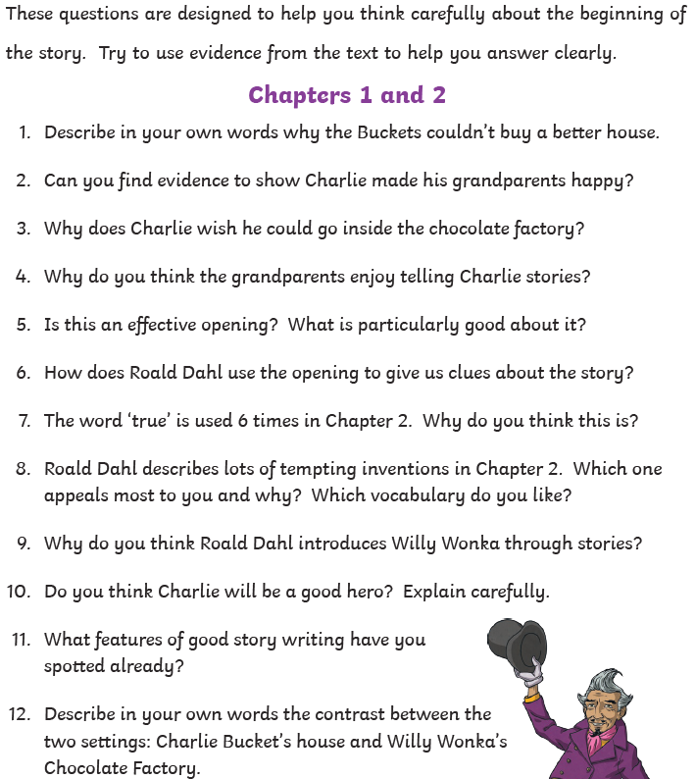

1 - Here Comes Charlie
These two very old people are the father and mother of Mr Bucket. Their names are Grandpa Joe and Grandma Josephine. And these two very old people are the father and mother of Mrs Bucket. Their names are Grandpa George and Grandma Georgina. This is Mr Bucket. This is Mrs Bucket. Mr and Mrs Bucket have a small boy whose name is Charlie. This is Charlie. How d'you do? And how d'you do? And how d'you do again? He is pleased to meet you. The whole of this family — the six grown-ups (count them) and little Charlie Bucket — live together in a small wooden house on the edge of a great town. The house wasn't nearly large enough for so many people, and life was extremely uncomfortable for them all. There were only two rooms in the place altogether, and there was only one bed. The bed was given to the four old grandparents because they were so old and tired. They were so tired, they never got out of it. Grandpa Joe and Grandma Josephine on this side, Grandpa George and Grandma Georgina on this side. Mr and Mrs Bucket and little Charlie Bucket slept in the other room, upon mattresses on the floor. In the summertime, this wasn't too bad, but in the winter, freezing cold draughts blew across the floor all night long, and it was awful. There wasn't any question of them being able to buy a better house — or even one more bed to sleep in. They were far too poor for that. Mr Bucket was the only person in the family with a job. He worked in a toothpaste factory, where he sat all day long at a bench and screwed the little caps on to the tops of the tubes of toothpaste after the tubes had been filled. But a toothpaste cap-screwer is never paid very much money, and poor Mr Bucket, however hard he worked, and however fast he screwed on the caps, was never able to make enough to buy one half of the things that so large a family needed. There wasn't even enough money to buy proper food for them all. The only meals they could afford were bread and margarine for breakfast, boiled potatoes and cabbage for lunch, and cabbage soup for supper. Sundays were a bit better. They all looked forward to Sundays because then, although they had exactly the same, everyone was allowed a second helping.
The Buckets, of course, didn't starve, but every one of them — the two old grandfathers, the two old grandmothers, Charlie's father, Charlie's mother, and especially little Charlie himself — went about from morning till night with a horrible empty feeling in their tummies. Charlie felt it worst of all. And although his father and mother often went without their own share of lunch or supper so that they could give it to him, it still wasn't nearly enough for a growing boy. He desperately wanted something more filling and satisfying than cabbage and cabbage soup. The one thing he longed for more than anything else was . . . CHOCOLATE. Walking to school in the mornings, Charlie could see great slabs of chocolate piled up high in the shop windows, and he would stop and stare and press his nose against the glass, his mouth watering like mad. Many times a day, he would see other children taking bars of creamy chocolate out of their pockets and munching them greedily, and that, of course, was pure torture. Only once a year, on his birthday, did Charlie Bucket ever get to taste a bit of chocolate. The whole family saved up their money for that special occasion, and when the great day arrived, Charlie was always presented with one small chocolate bar to eat all by himself. And each time he received it, on those marvellous birthday mornings, he would place it carefully in a small wooden box that he owned, and treasure it as though it were a bar of solid gold; and for the next few days, he would allow himself only to look at it, but never to touch it. Then at last, when he could stand it no longer, he would peel back a tiny bit of the paper wrapping at one corner to expose a tiny bit of chocolate, and then he would take a tiny nibble — just enough to allow the lovely sweet taste to spread out slowly over his tongue. The next day, he would take another tiny nibble, and so on, and so on. And in this way, Charlie would make his sixpenny bar of birthday chocolate last him for more than a month. But I haven't yet told you about the one awful thing that tortured little Charlie, the lover of chocolate, more than anything else. This thing, for him, was far, far worse than seeing slabs of chocolate in the shop windows or watching other children munching bars of creamy chocolate right in front of him. It was the most terrible torturing thing you could imagine, and it was this: In the town itself, actually within sight of the house in which Charlie lived, there was an ENORMOUS CHOCOLATE FACTORY! Just imagine that! And it wasn't simply an ordinary enormous chocolate factory, either. It was the largest and most famous in the whole world! It was WONKA'S FACTORY, owned by a man called Mr Willy Wonka, the greatest inventor and maker of chocolates that there has ever been. And what a tremendous, marvellous place it was! It had huge iron gates leading into it, and a high wall surrounding it, and smoke belching from its chimneys, and strange whizzing sounds coming from deep inside it. And outside the walls, for half a mile around in every direction, the air was scented with the heavy rich smell of melting chocolate! Twice a day, on his way to and from school, little Charlie Bucket had to walk right past the gates of the factory. And every time he went by, he would begin to walk very, very slowly, and he would hold his nose high in the air and take long deep sniffs of the gorgeous chocolatey smell all around him. Oh, how he loved that smell! And oh, how he wished he could go inside the factory and see what it was like!

2 Mr Willy Wonka's Factory
In the evenings, after he had finished his supper of watery cabbage soup, Charlie always went into the room of his four grandparents to listen to their stories, and then afterwards to say good night. Every one of these old people was over ninety. They were as shrivelled as prunes, and as bony as skeletons, and throughout the day, until Charlie made his appearance, they lay huddled in their one bed, two at either end, with nightcaps on to keep their heads warm, dozing the time away with nothing to do. But as soon as they heard the door opening, and heard Charlie's voice saying, 'Good evening, Grandpa Joe and Grandma Josephine, and Grandpa George and Grandma Georgina,' then all four of them would suddenly sit up, and their old wrinkled faces would light up with smiles of pleasure — and the talking would begin. For they loved this little boy. He was the only bright thing in their lives, and his evening visits were something that they looked forward to all day long. Often, Charlie's mother and father would come in as well, and stand by the door, listening to the stories that the old people told; and thus, for perhaps half an hour every night, this room would become a happy place, and the whole family would forget that it was hungry and poor. One evening, when Charlie went in to see his grandparents, he said to them, 'Is it really true that Wonka's Chocolate Factory is the biggest in the world?' 'True?' cried all four of them at once. 'Of course it's true! Good heavens, didn't you know that? It's about fifty times as big as any other!' 'And is Mr Willy Wonka really the cleverest chocolate maker in the world?' 'My dear boy,' said Grandpa Joe, raising himself up a little higher on his pillow, 'Mr Willy Wonka is the most amazing, the most fantastic, the most extraordinary chocolate maker the world has ever seen! I thought everybody knew that!'
'I knew he was famous, Grandpa Joe, and I knew he was very clever . . .' 'Clever!' cried the old man. 'He's more than that! He's a magician with chocolate! He can make anything — anything he wants! Isn't that a fact, my dears?' The other three old people nodded their heads slowly up and down, and said, 'Absolutely true. Just as true as can be.' And Grandpa Joe said, 'You mean to say I've never told you about Mr Willy Wonka and his factory?' 'Never,' answered little Charlie. 'Good heavens above! I don't know what's the matter with me!' 'Will you tell me now, Grandpa Joe, please?' 'I certainly will. Sit down beside me on the bed, my dear, and listen carefully.' Grandpa Joe was the oldest of the four grandparents. He was ninety-six and a half, and that is just about as old as anybody can be. Like all extremely old people, he was delicate and weak, and throughout the day he spoke very little. But in the evenings, when Charlie, his beloved grandson, was in the room, he seemed in some marvellous way to grow quite young again. All his tiredness fell away from him, and he became as eager and excited as a young boy. 'Oh, what a man he is, this Mr Willy Wonka!' cried Grandpa Joe. 'Did you know, for example, that he has himself invented more than two hundred new kinds of chocolate bars, each with a different centre, each far sweeter and creamier and more delicious than anything the other chocolate factories can make!' 'Perfectly true!' cried Grandma Josephine. 'And he sends them to all the four corners of the earth! Isn't that so, Grandpa Joe?' 'It is, my dear, it is. And to all the kings and presidents of the world as well. But it isn't only chocolate bars that he makes. Oh, dear me, no! He has some really fantastic inventions up his sleeve, Mr Willy Wonka has! Did you know that he's invented a way of making chocolate ice cream so that it stays cold for hours and hours without being in the refrigerator? You can even leave it lying in the sun all morning on a hot day and it won't go runny!' 'But that's impossible!' said little Charlie, staring at his grandfather. 'Of course it's impossible!' cried Grandpa Joe. 'It's completely absurd! But Mr Willy Wonka has done it!' 'Quite right!' the others agreed, nodding their heads. 'Mr Wonka has done it.' 'And then again,' Grandpa Joe went on speaking very slowly now so that Charlie wouldn't miss a word, 'Mr Willy Wonka can make marshmallows that taste of violets, and rich caramels that change colour every ten seconds as you suck them, and little feathery sweets that melt away deliciously the moment you put them between your lips. He can make chewing-gum that never loses its taste, and sugar balloons that you can blow up to enormous sizes before you pop them with a pin and gobble them up. And, by a most secret method, he can make lovely blue birds' eggs with black spots on them, and when you put one of these in your mouth, it gradually gets smaller and smaller until suddenly there is nothing left except a tiny little pink sugary baby bird sitting on the tip of your tongue.' Grandpa Joe paused and ran the point of his tongue slowly over his lips. 'It makes my mouth water just thinking about it,' he said. 'Mine, too,' said little Charlie. 'But please go on.' While they were talking, Mr and Mrs Bucket, Charlie's mother and father, had come quietly into the room, and now both were standing just inside the door, listening. 'Tell Charlie about that crazy Indian prince,' said Grandma Josephine. 'He'd like to hear that.' 'You mean Prince Pondicherry?' said Grandpa Joe, and he began chuckling with laughter.
'Completely dotty!' said Grandpa George. 'But very rich,' said Grandma Georgina. 'What did he do?' asked Charlie eagerly. 'Listen,' said Grandpa Joe, 'and I'll tell you.'

SPAG Task 3
Using your preposition list from task 1, create several sentences about the beginning of our text, which include prepositional phrases e.g. Charlie’s is on the floor next to the window.

Maths Task 3
The next step in your maths work is to learn to use formal written methods to multiply numbers – we will start with 2-digit by 2-digit
23
x 14
92 (23 x 4)
230 (23 x 10)
322

1. 36 x 12 = 4. 48 x 15 =
2. 43 x 16 = 5. 61 x 13 =
3. 55 x 14 =

Now have a go at these:
1. 32 x 24 =
2. 46 x 28 =
3. 59 x 26 =

Joe has answered 47 x 36 as 323
Alice says “the answer should be 1692 not 323”
Who is correct? Explain how you know
Science
Which materials dissolve in a liquid to form a solution?
Firstly, find and explain what the term ‘solution’ means.
Work through the attached slides which are on the Year 5 page of the school website and then find out what happens to salt or sugar if you add it to water? Record your findings.
Can you think of any other materials that would dissolve, react or float or sink? Finally, is it possible to get the salt back from the salt water solution? If so how would you do this, perhaps you could share some photographs with your class teacher of your experiment via Class Dojo.

Geography
Can I name and locate the capital cities of European countries?
What is a capital city?
Watch the video (link below) which takes you to each of the countries that make up the continent of Europe.
https://www.youtube.com/watch?app=desktop&v=07Zoc5fgoOA#
Choose eight countries, in Europe, identify their capital city (remember your capital letters!) and locate where in each country they are situated. What landmarks can be found in these cities e.g. buildings, cathedrals, monuments, castles etc.

Art
Using these examples of chocolate bar wrappers, choose one to sketch and colour in detail. Make sure you look carefully at the letter shapes and colours so you can match these exactly (no tracing!).

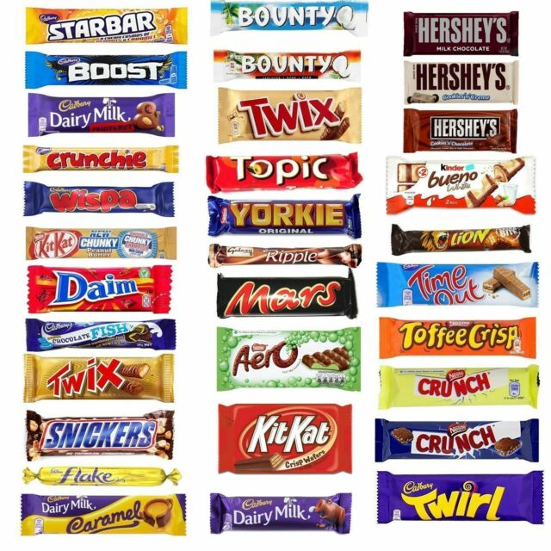

Make sure that you include a physical activity each day – a walk, bike ride, a game of football in your garden, etc.

