Science
Will it float?
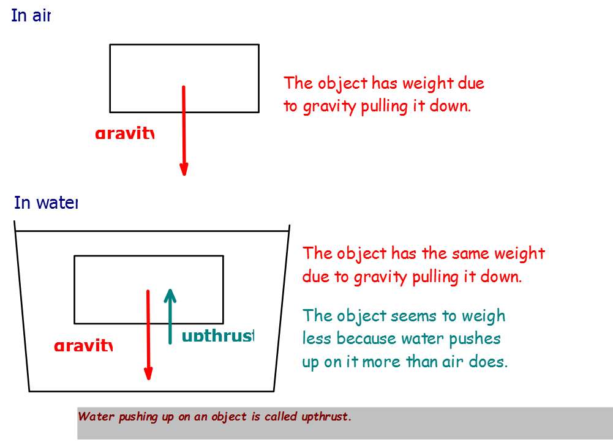

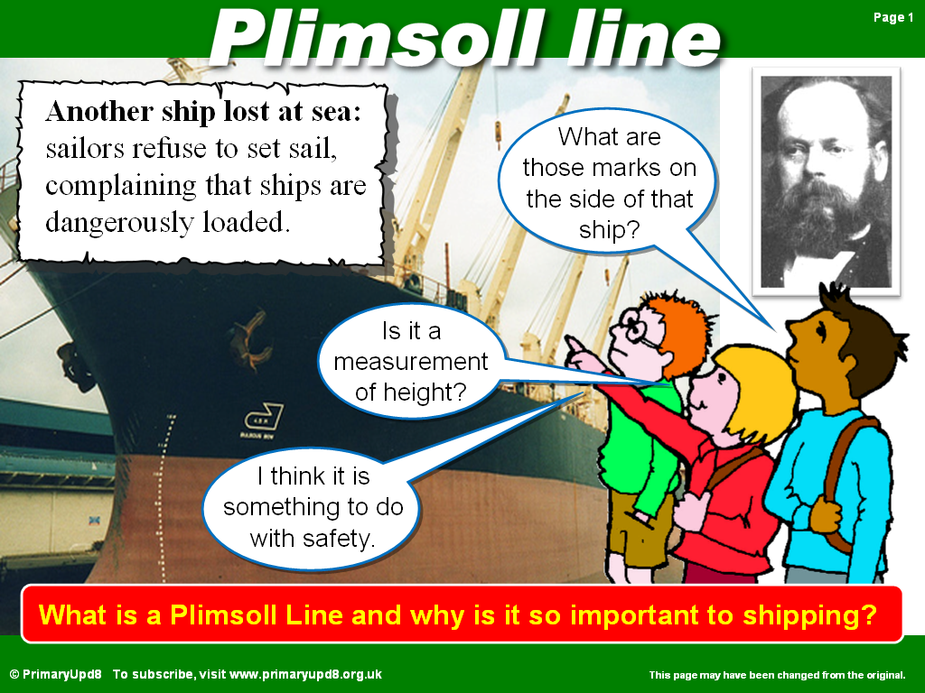
Last week in science we started to make a boat to test what happens to the plimsoll line
1, in cold water
2, in warm water
3, in salt water
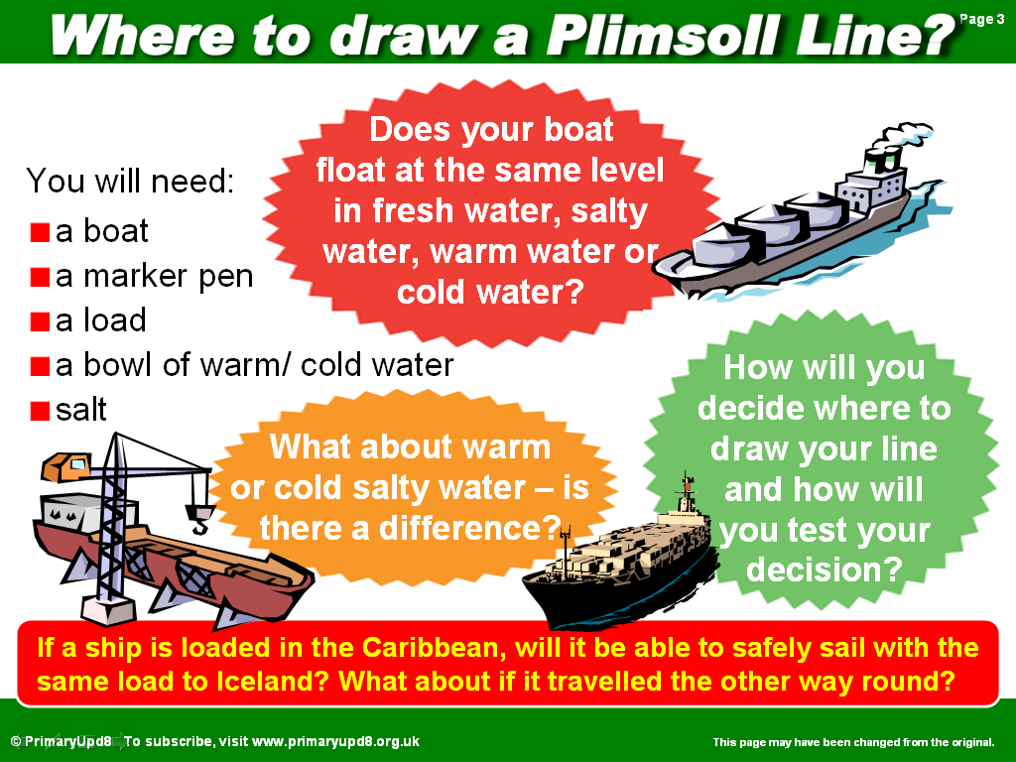

Build a boat and then put it in a sink of cold water and mark the plimsoll line with a marker pen. You will need to put some weight on your boat but not too much!
Do the same with warm water and mark the plimsoll line.
Repeat in salt water.

What did you notice?

How see how much weight your boat will take before it sinks.

