RE
Thursday 6th May 2021
What is a rite of passage?
A rite of passage is an important event that takes place in your life.
Watch the video for an example of a person’s common life events:
https://www.youtube.com/watch?v=jYOsWWKHZVw
Can you draw a timeline of important events that have taken place in your life so far?
These might include being born, birthdays, your first tooth, starting school, learning to ride your bike etc.
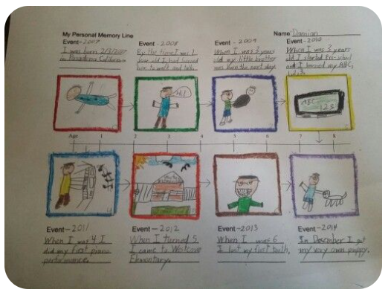
It could look similar to the example above but you can present your own timeline however you wish.

