History
Wednesday 5th May 2021
Who was Queen Elizabeth I?
Listen to the following BBC Schools radio extract and make notes about Queen Elizabeth I.
https://www.bbc.co.uk/teach/school-radio/history-tudors-elizabeth-i/z6cbscw
See if you can answer the following questions: When was she born? Where was she born? When was she Queen? What sort of person was she? Did she marry? Did she have children? When did she die? You may also need to do some research of your own.
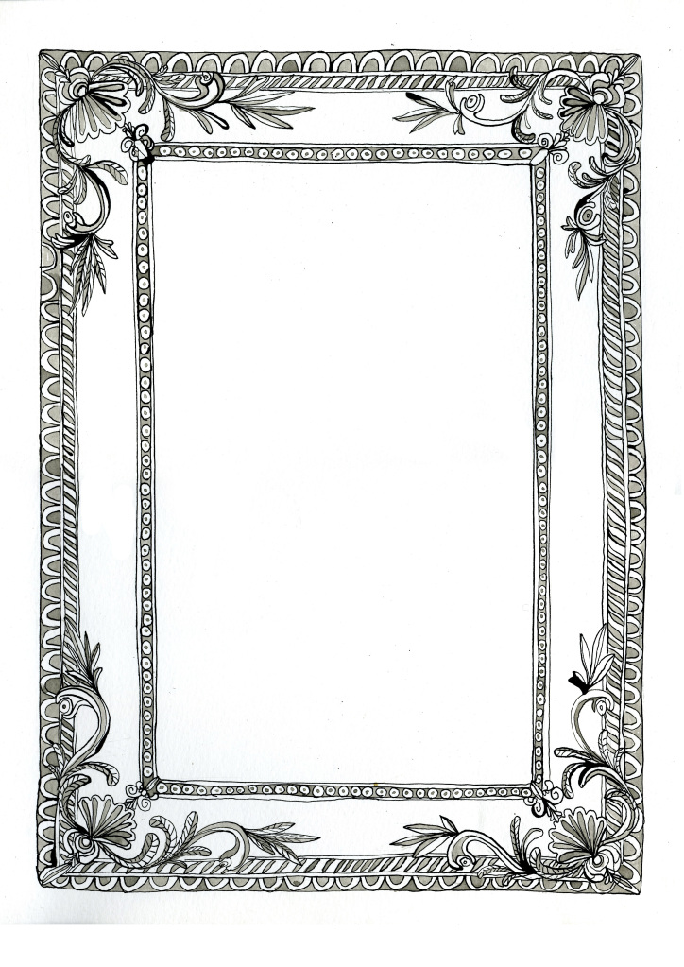
There is a picture frame below. Add a portrait of Queen Elizabeth I.

