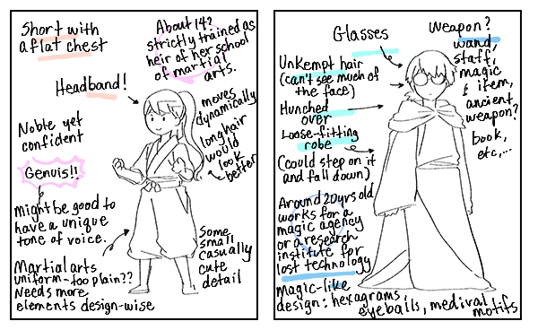
Big Write
Friday 7th May 2021
Can you describe your main characters?
Draw and describe your main character and
Their side-kick in as much detail as possible.
Add notes to describe them both.
Remember to include:
- Name
- Age (roughly old / young)
- Personality - brave, scared, clumsy etc
- Relationship - how did they meet?
- Why chosen for quest?
- Likelihood of succeeding?
- descriptive words / phrases

Now, in preparation for next week, can you think about the opening section of your story. Look again at your plan and see if you can break down the opener into about 5 or 6 main events. E.g.

- leader says they need the magic herb
- It is hard to find
- No-one wants to go
- Main character offers to go
- Everyone laughs at him
- He grabs the map and sets off with friend

