SPAG
https://www.theschoolrun.com/what-is-a-semi-colon
Use the website above to learn about the use of colons and semi-colons.

Look at these examples of using a colon.
Baby bear: Who's eating my porridge?

This is one of the most famous lines Shakespeare wrote: To be or not to be? ...

She went to the shops and bought apples, oranges and bananas.

She bought the following items: apples, oranges and bananas.

It snowed all night: the children knew the trip would be cancelled.

Colons introduce something. In the first one it uses a colon to introduce what a character is about to say in a play script. The second one is before a quote. The third doesn’t need one because it doesn’t formally introduce a list. The forth one formally introduces a list. And finally, the last one has two main clauses where the first introduces the second.

Task 1

Can you create sentences using a colon likes the ones above.

Task 2
Look at the use of the semi-colon below each time.

The following children will miss their lunchtime: Mark, for kicking the ball over the fence; Claire for talking back to the dinner lady; and David for making fun of Demi.

Some people prefer tea; some people prefer coffee.

The rain poured; the wind howled.

Above the semi-colon has been used in a detailed list instead of a comma. In the last two it has been used to separate two main clauses that are related to each other.

Use the images below to create twos sentences each time using a semi-colon, one for a detailed list and secondly to link closely related sentences.

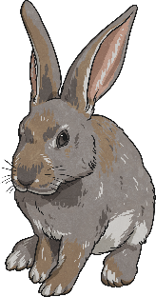


Task 3
Place in semi-colons or colons correctly into the sentences below. Give reasons for your answers each time.

1. The school fair was a huge success over £800 was raised for the new library.
Your reason:
2. I spent the afternoon playing tennis my best friend spent the afternoon playing football.
Your reason:
3. The following items were collected for the treasure hunt a gold chain that was my fathers a map that had previously been used to find gold and a compass to find north.
Your reason:
4. Fred was late for school, he had missed the bus.
Your reason:
5. Putting up a tent is hard work I don’t think I will be going camping again.
Your reason:
6. Aladdin I’m not really sure I can be trusted with the lamp.
Your reason:
Task 4
Imagery is used in writing to help paint a picture for the reader. Imagery is often seen when we use similes, personification and metaphors in our writing. Using the modelled example below to help you structure your work, can you write a description of 15th century London?

London

Elegantly, boats drifted down the overcrowded, dirt filled river. Like rotten eggs, the stench coming from the water smelt vile. Disgusting! This was a city where people never stopped. Chimneys coughed out smoke as the people below them hustled and bustled. The smell of coal filled their lungs. Even though life seemed more exciting here, this could never be home. Where were the green fields and rolling hills? Gigantic buildings and churches guarded the streets, some even had tiled roofs! Horses trotted solemnly past steered by men in uniform. Excited, their hooves clanked noisily on the cobbled streets. The streets were a hive of activity. All around you, you could see disease, heartache and sorrow everywhere.
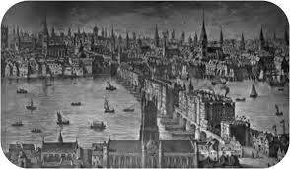

Task 5
Can you now use the new modelled example to write a setting description of modern day London?

Handsomely, Big Ben stands to attention as the ant like people take pictures of his face. Below, the streets are filled with footsteps moving loudly and merrily on their way. Rather than take in the wonderful colours that surround them, men in suits are distracted by the sound of mobile phones. London is alive with colour. Wow! Excited Children inquisitively gaze up at their parents. The river Thames is a snake slithering wildly to the sea. Does London ever pause for breath? Will the cars stranded helplessly on black tarmac ever move? The city watches, waits and considers the next day ahead.
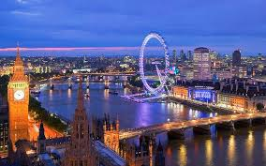

Task 6
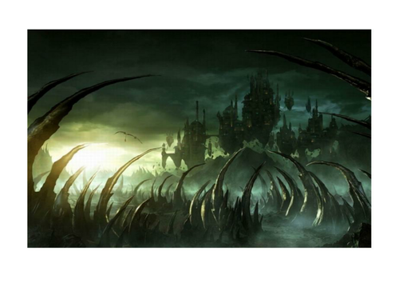
Use one of the images to create your own setting description using imagery.


