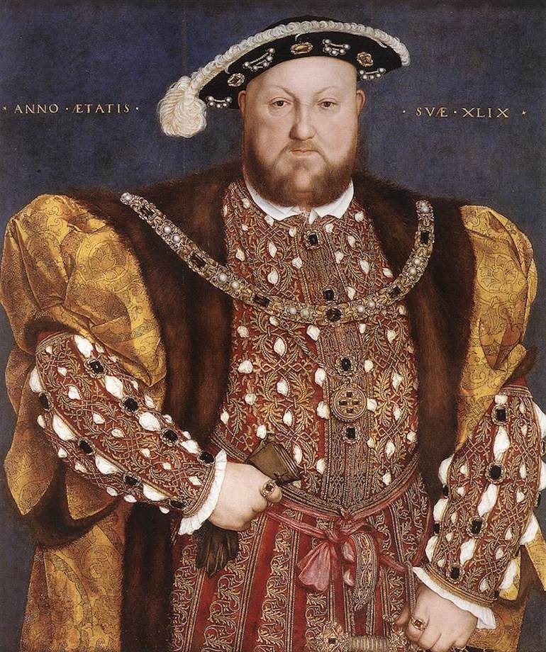
History
Wednesday 28th April 2021
Who was Henry the VIII?

Can you research King Henry VIII and write a fact-file about his life? When was he born? Where was he born? When did he become King? Did he get married? Did he have children? When did he die?
You could also include a portrait to add to your fact-file.

