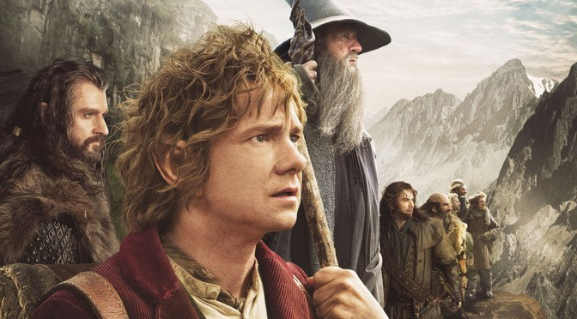
Big Write
Friday 30th April 2021
Can you plan an adventure story?

Look at the modelled example below and then use the plan on the next page to roughly think of an idea for an adventure story. We will be writing this together over a series of weeks during Big Write.

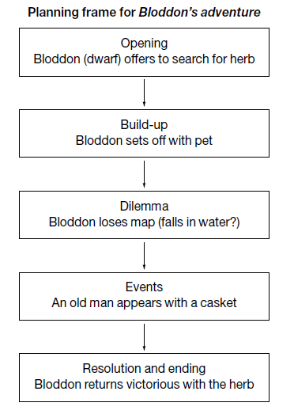

Adventure story - planning frame
Opening
Resolution and ending
Events
Dilemma
Build-up

