Science 26.04.21

Look at each image below and create a list of which items need switches.
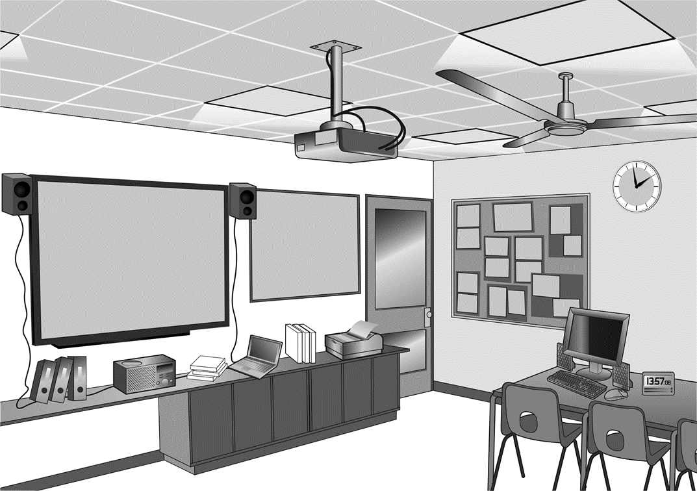

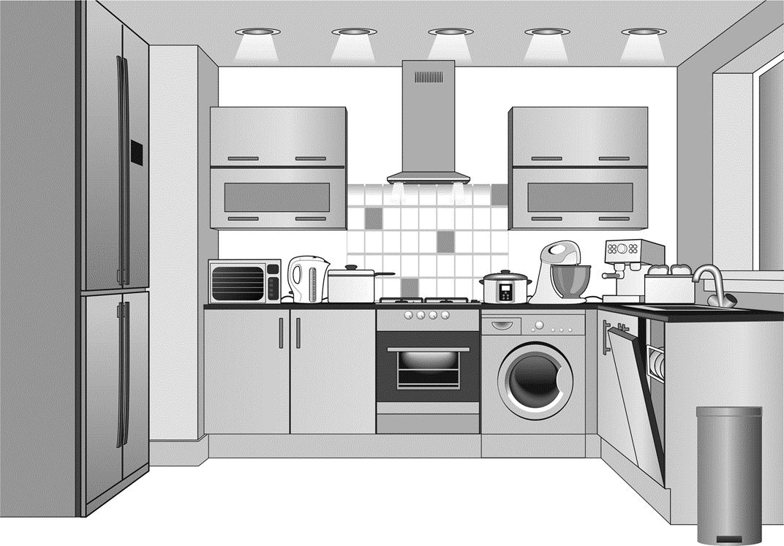

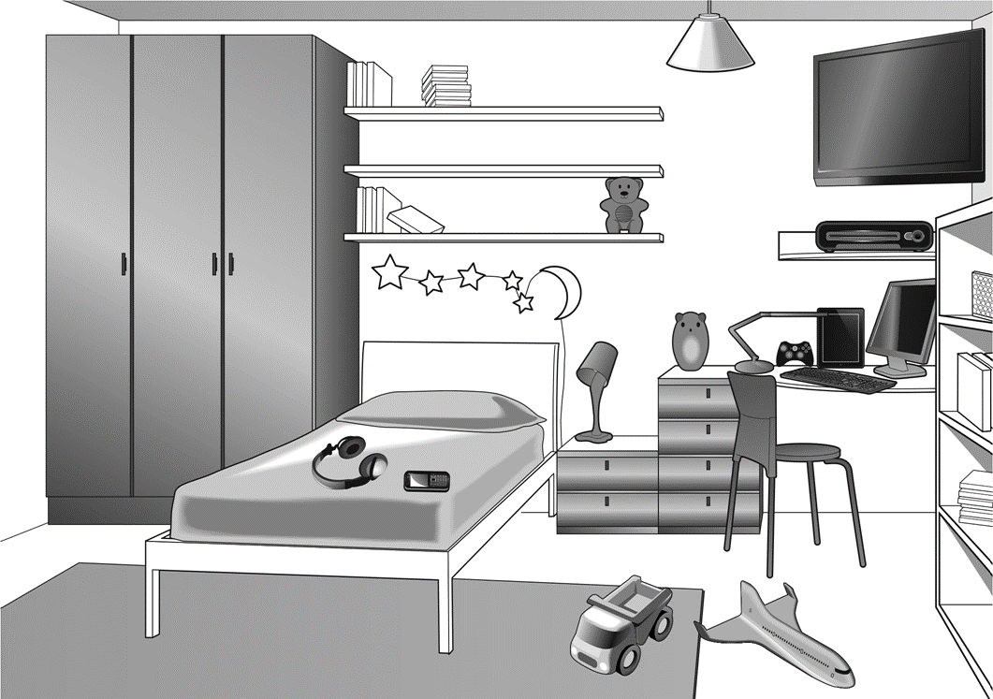

Have a look at the website below.
https://www.bbc.co.uk/bitesize/topics/zq99q6f/articles/zt8vg82

