SPAG
Task 1.

Below is a list of ways you can start a sentence to make sure you don’t use the same technique each time.
Adverb opener
Prepositional opener
Adjective opener
Simile opener
One word opener
ing opener
ed opener

Here is an example of how to use them although the sentences haven’t all been finished.

Quietly...
On the other side of the lane...
Dark trees towered over the lane...
Like a greyhound...
Weary...
Running for home, Mrs case tripped...
Excited by the cakes, Mrs Case ran home...

Use the image below to complete 7 different complete sentences using each sentence opener technique.

E.g. 1. Nervously, the ladies danced around the King.

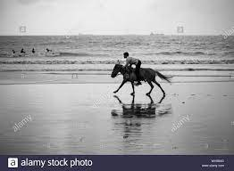
Can you do 7 for this image using each sentence opener technique?

Task 2
We are also looking at the impact of different sentences in our writing. Below is some examples of different ones.
Short simple sentence for drama and clarity:
Smoking is unhealthy.
Compound sentences for flow:
Joe hopped and Sally ran.
Complex sentence to add in extra layers of information:
As Louie walked alone, Mr Saunders ate the doughnut.
Question to draw in the reader:
What was it?
Exclamation for impact:
Just jump!
Sentence of 3 for detail:
She wore a long dress, black shoes and a red hat.
Sentence of 3 for action:
Ollie ran down the road, jumped over the wall and collapsed.

Can you use an example of each one to create 7 different sentence types for the images below? So 14 complete sentences in total.

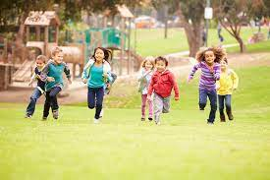


English.
We will be writing a diary entry in the shoes of William after his father makes him try the family ring on. We will also need to consider how he is feeling after the tragic death of his brother in the first chapter. Here is my example to help you.

Dear Diary,

Forlorn! That's how I felt when I entered the dark, damp room. Like the walls were closing in on me, I struggled to catch my breath. Nervously I walked over to father who seemed troubled. It was like the world had stopped that day.

Staring at the ground, I didn't want to make eye contact with him as I knew he blamed me. Although I was anxious, I couldn't help but feel huge pride that my father had entrusted me with the families precious jewel. It sparkled like a sword-blade in the sunshine. Beautiful!
Its weight seemed heavy on my finger and I could tell it would take some time before it gripped the skin around it. Maybe then I would deserve it?

What the next few months will bring I'm unsure of diary? Will father still be here to protect us? Will Aunt Carew be as cruel as we all remember her to be? Will the pain of our dear brother's death ever heal? So many questions have been left unanswered. I hope that we find my beloved, gentle brother's body soon so we can find some peace.

Can you find the key criteria below in the example and then also include them in your own?

Key criteria of diary entries.

First person
Feelings and emotion
Rhetorical questions
Mainly in the past tense.
Future tense towards the end of the entry.

Also include set writing expectations:
Simile
Complex sentence
Fronted adverbial
Expanded noun phrase
Questions

