Year 6 Term 3 Curriculum: Has the world gone bananas?
As Coningsby believers we will:
Learn about Compassion through the Bible story: Feeding the 5000 John 6 v 1-44

In RE will be exploring the Christian story of creation and also the scientific big bang and looking at whether these are conflicting or complementary ideas.
Dear parents of Year 6:
We hope you’ve had a fantastic Christmas holiday.
Please remember this term…
- P.E. will be on a Tuesday and Thursday
- Homework will be set on Fridays and due in on Thursdays
- Spellings should be practised as part of weekly homework
- Times Table Rock Star sessions should be completed as part of weekly homework.
- Children need to read everyday.
As Coningsby Mathematicians we will:

Be looking at how to solve problems with fractions using all 4 operations.
We will also be exploring decimals and percentages and the connections between them.

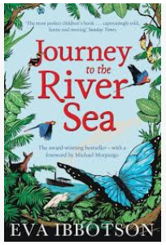

As Coningsby Authors we will:
Be studying the book ‘Journey to the River Sea’ by Eva Ibbotson and from this, we will:

Explore the characters in the story
Write a newspaper report
Write a non-chronological report
Write poetry using imagery

As Coningsby Geographers we will be exploring:
Climate change:
What is climate change?
What are the causes and effects of extreme weather?
How do time zones work?
How do I use an atlas to locate places?

As Coningsby Scientists we will:
Be looking at electrical circuits-
How can you light up your life?
We will explore how voltage links to the brightness of a lamp or volume of a buzzer. We will give reasons why components work and do not work within a circuit and learn to draw circuit diagrams using correct symbols.
As Coningsby Artists & Designers we will:
Be exploring portraits and self-portraits this term.
We will look at the work of different artists including Frida Kahlo and will try to recreate some of their work using specific techniques such as collage, painting and observational drawing.

